**Report – 1**

**Summary**

This retrieves all data from the bank_loan_data table

1. select * from bank_loan_data -- You will see data

Open the Problem Statement and start solving it

**Summary Report**

**KPI's**

**1) Total Loan Applications:** We need to calculate the total number of loan applications received during a specified period. Additionally, monitoring the Month-to-Date (MTD) Loan Applications and tracking changes Month-over-Month (MoM) is essential.

**Month to Date Total_loan_Application**

1) SELECT count(id) AS Total_loan_Application from bank_loan_data

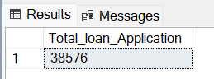

**Month to Date Total_loan_Application**

1. SELECT count(id) AS MTD_Total_loan_Application from bank_loan_data

WHERE MONTH(issue_date) = 12 AND YEAR (issue_date) = 2021

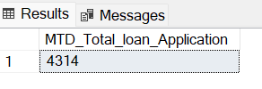

**Previous Month to Date Total_loan_Application**

SELECT count(id) AS PMTD_Total_loan_Application

FROM bank_loan_data

WHERE MONTH(issue_date) = 11 AND YEAR(issue_date) = 2021

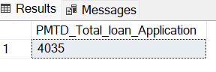

**Month on Month** = (MTD – PMTD) / PMTD

**2 ) Total Funded Amount:** Understanding the total amount of funds disbursed as loans is crucial. We also want to keep an eye on the MTD Total Funded Amount and analyse the Month-over-Month (MoM) changes in this metric**.**

**Total Funded amount**

SELECT SUM(loan_amount) AS Total_funded_Amount FROM bank_loan_data



**Month to Date Total Funded Amount**

SELECT SUM(loan_amount) AS MTD_Total_funded_Amount FROM bank_loan_data

where month(issue_date) = 12 AND YEAR(issue_date) = 2021

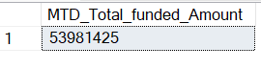

**Previous Month to Date Total Funded Amount**

SELECT SUM(loan_amount) AS PMTD_Total_Funded_Amount

FROM bank_loan_data

WHERE MONTH(issue_date) = 11 AND YEAR(issue_date)=2021

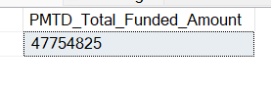

**Month on Month** = (MTD – PMTD) / PMTD

**3) Total Amount Received:** Tracking the total amount received from borrowers is essential for assessing the bank's cash flow and loan repayment We should analyse the Month-to-Date (MTD) Total Amount Received and observe the Month-over-Month (MoM) changes.

**Total Amount Received**

SELECT SUM(total_payment) As Total_Amount_received FROM bank_loan_data

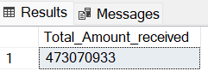

**Month to Date Total Amount Received**

SELECT SUM(total_Payment) AS MTD_Total_Amount_Received

FROM bank_loan_data

WHERE MONTH(issue_date) = 12 AND YEAR(issue_date) =2021

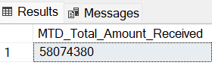

**Previous Month to Date Total Amount Received**

SELECT SUM(total_payment) AS PMTD_Total_Amount_Received

FROM bank_loan_data

WHERE Month(issue_date) = 11 AND YEAR(issue_date) = 2021

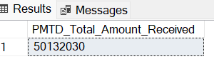

**Month on Month** = (MTD – PMTD) / PMTD

1. **Average Interest Rate:** Calculating the average interest rate across all loans, MTD, and monitoring the Month-over-Month (MoM) variations in interest rates will provide insights into our lending portfolio's overall cost**.**

**Average Interest Rate**

SELECT ROUND(AVG(int_rate), 4) * 100 AS Avg_Interest_Rate FROM bank_loan_data

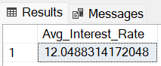

**Month to Date Avg Interest Rate**

SELECT ROUND(AVG(int_rate), 4) * 100 AS MTD_Avg_Interest_Rate

FROM bank_loan_data

WHERE MONTH(issue_date) = 12 AND YEAR(issue_date) = 2021

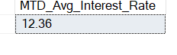

**Previous Month Avg Interest Rate**

SELECT ROUND(AVG(int_rate), 4) * 100 AS PMTD_Avg_Interest_Rate

FROM bank_loan_data

WHERE MONTH(issue_date) = 11 AND YEAR(issue_date) = 2021

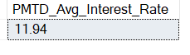

**Month on Month** = (MTD – PMTD) / PMTD

1. **Average Debt-to-Income Ratio (DTI):** Evaluating the average DTI for our borrowers helps us gauge their financial health. We need to compute the average DTI for all loans, MTD, and track Month-over-Month (MoM) fluctuations.

**The Avg Depth to Income Ratio**

SELECT ROUND(AVG(dti) , 4) * 100 AS Avg_DTI FROM bank_loan_data

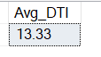

**Month to Date DTI Ratio**

SELECT ROUND(AVG(dti) , 4) * 100 AS MTD_Avg_DTI

FROM bank_loan_data

WHERE MONTH(issue_date) = 12 AND YEAR(issue_date) = 2021

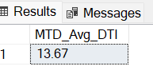

**Previous Month DTI Ratio**

SELECT ROUND(AVG(dti) , 4) * 100 AS MTD_Avg_DTI

FROM bank_loan_data

WHERE MONTH(issue_date) = 11 AND YEAR(issue_date) = 2021

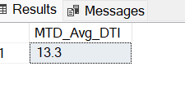

**Good Loan Vs Bad Loans**

**Good Loan Application Percentage**

SELECT

(COUNT(CASE WHEN loan_status ='Fully Paid ' or loan_status ='Current' THEN id END ) * 100 )

/

COUNT(id) AS Good_loan_percentage

FROM bank_loan_data

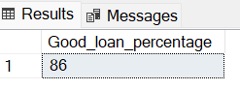

**Good Loan Application**

SELECT count(id)AS Good_loan_Application FROM bank_loan_data

WHERE loan_status = 'Fully Paid' OR Loan_status = 'Current'

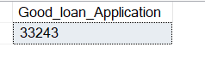

**Good Loan Funded Amount**

SELECT SUM(loan_amount) AS Good_loan_Funded_Amount FROM bank_loan_data

WHERE loan_status = 'Fully Paid' OR loan_status ='Current'

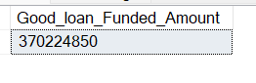

**Good Loan Received Amount**

SELECT SUM(total_payment) AS Good_Loan_Received_Amount FROM bank_loan_data

WHERE loan_status ='Fully Paid' OR loan_status = 'Current'



**BAD LOAN PERCENTAGE**

SELECT

(COUNT(CASE WHEN loan_status = 'Charged Off' THEN id END ) * 100.0) / COUNT(id) AS Bad_Loan_Percentage

FROM bank_loan_data



**Total Bad Loan Application**

SELECT COUNT(id) AS Bad_Loan_Applications FROM bank_loan_data

WHERE loan_status = 'Charged Off'



**Total Bad Loan Amount**

SELECT SUM(loan_amount) AS Bad_Loan_Amount FROM bank_loan_data WHERE loan_status = 'Charged Off'



**Total Bad Loan Amount Received**

SELECT sum(total_payment) AS Bad_Loan_Amount_Received FROM bank_loan_data

WHERE loan_status = 'Charged Off'

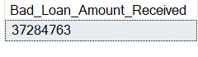

**Loan Status Grid View**

SELECT

loan_status,

COUNT(id) AS Total_loan_Applications,

SUM(total_payment) AS Total_Amount_Received,

SUM(loan_amount) AS Total_Funded_Amount,

AVG(int_rate * 100) AS Interest_Rate,

AVG(dti * 100) AS DTI

FROM bank_loan_data

GROUP BY loan_status

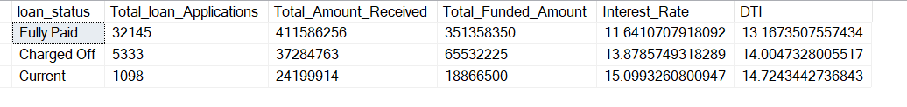

SELECT

loan_status,

SUM(total_payment) AS MTD_Total_Amount_Received,

SUM(loan_amount) AS MTD_Total_Funded_Amount

FROM bank_loan_data

WHERE MONTH(issue_date) = 12

GROUP BY loan_status

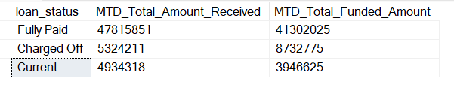

REPORT - 2

OVERVIEW

1. **Monthly Trends by Issue Date (Line Chart):**  To identify seasonality and long-term trends in lending activities

SELECT

MONTH(issue_date) AS Month_Number,

DATENAME(MONTH,issue_date) AS Month_Name,

COUNT(id) AS Total_Loan_Applications,

SUM(loan_amount) AS Total_Funded_Amount,

SUM(total_payment) AS Total_Received_Amount

FROM bank_loan_data

GROUP BY MONTH(issue_date), DATENAME(MONTH , issue_date)

ORDER BY MONTH(issue_date)

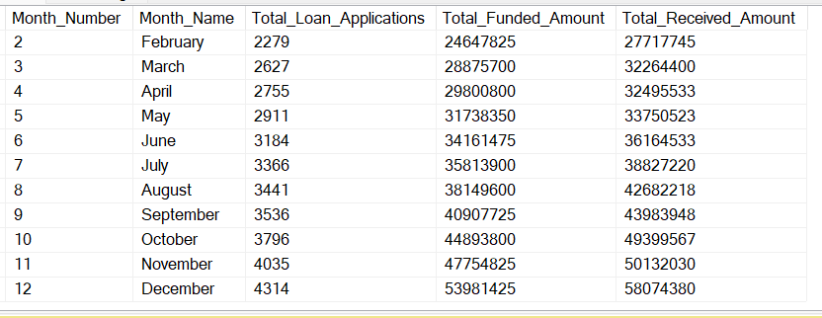



1. **Regional Analysis by State (Filled Map):** To identify regions with significant lending activity and assess regional disparities

SELECT address_state,

Count(id) AS Total_Loan_Applications,

SUM(loan_amount) AS Total_Funded_Amount,

SUM(total_payment) AS Total_Received_Amount

FROM bank_loan_data

GROUP BY address_state

ORDER BY count(id) DESC

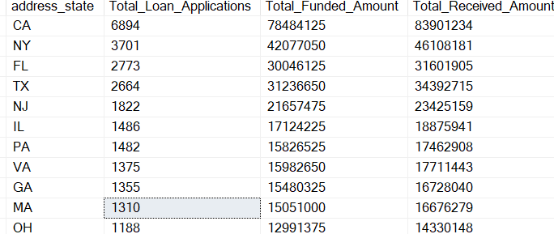

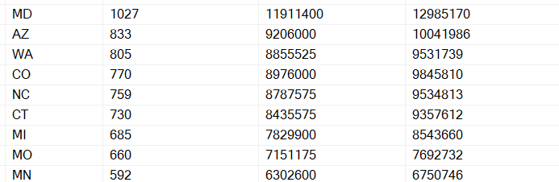

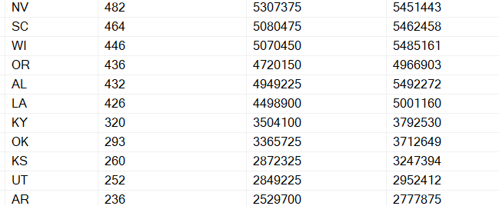

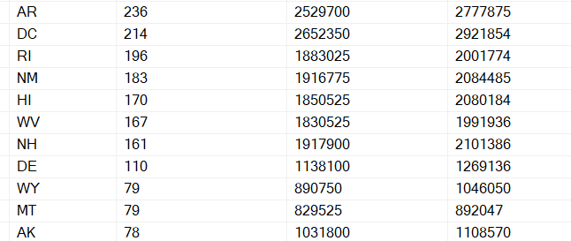

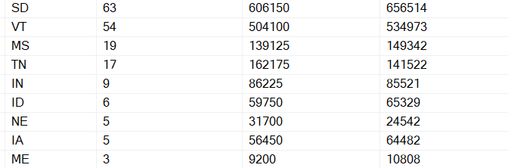

1. **Loan Term Analysis (Donut Chart):** To allow the client to understand the distribution of loans across various term lengths.

SELECT term,

COUNT(id) AS Total_Loan_Applications,

SUM(loan_amount) AS Total_Funded_Amount,

SUM(total_payment) AS Total_Received_Amount

FROM bank_loan_data

GROUP BY term

ORDER BY term

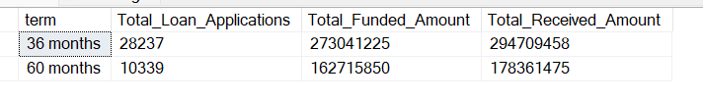

1. **Employee Length Analysis (Bar Chart):** How lending metrics are distributed among borrowers with different employment lengths, helping us assess the impact of employment history on loan applications.

SELECT emp_length,

COUNT(id) AS Total_Loan_Applications,

SUM(loan_amount) AS Total_Funded_Amount,

SUM(total_payment) AS Total_Received_Amount

FROM bank_loan_data

GROUP BY emp_length

ORDER BY emp_length

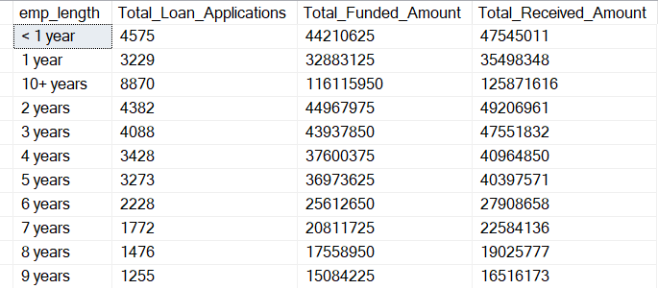

1. **Loan Purpose Breakdown (Bar Chart):** Will provide a visual breakdown of loan metrics based on the stated purposes of loans, aiding in the understanding of the primary reasons borrowers seek financing.

SELECT purpose,

COUNT(id) AS Total_loan_Applications,

SUM(loan_amount) AS Total_Funded_Ammount,

SUM(total_payment) AS Total_Received_Amount

FROM bank_loan_data

GROUP BY purpose

ORDER BY count(id) DESC

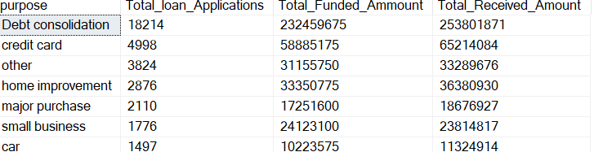

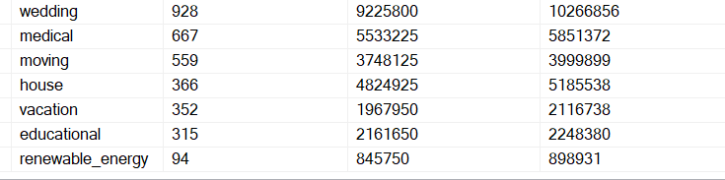

1. **Home Ownership Analysis (Tree Map):** For a hierarchical view of how home ownership impacts loan applications and disbursements.

SELECT home_ownership,

COUNT(id) AS Total_Loan_Applications,

SUM(loan_amount) AS Total_Funded_Amount,

SUM(total_payment) AS Total_Received_Amount

FROM bank_loan_data

GROUP BY home_ownership

ORDER BY COUNT(id) DESC

